02nd April 2019

**FIA WTCR Kicks-off with the Race of Morocco at the weekend**

The 2019 WTCR – FIA World Touring Car Cup which has the Japanese premium tyre manufacturer YOKOHAMA as exclusive tyre supplier has attracted a high-level entry with 26 all-season racers set for battle from this weekend’s curtain-raiser in Morocco to the super-finale in Malaysia in mid-December.

Headed by the 2018 WTCR title winner, Italian veteran Gabriele Tarquini, the entry consists of 13 teams representing seven customer racing brands and nine new drivers to WTCR.

On the list are seven FIA world title winners and 12 drivers who claimed race victories in last season’s WTCR glory chase. A total of 43 major titles have been won by the 26 season-long racers, while the flags of 14 different countries will be flown.

According to the WTCR promoter, “The variety of cars, the level of customer teams, the amount of champions, the mix of generations of drivers and the spread of forces across the field will make WTCR a unique flagship for the entire global TCR category. The #WTCR2019SUPERGRID is probably the best international touring car entry list we have seen in decades, certainly a level above 2018. I expect nothing else than 20 cars within one second in qualifying, fights at every level in all 30 races, plus one great champion crowned in Malaysia on 15 December.” said Francois Ribeiro of Eurosport Events.

For its part, a spokesman for YOKOHAMA Europe expressed excitement with the upcoming races and wished all the competitors the best of luck. “Our Motorsport support team is ready to assist with the technical knowledge and we wish all the teams and drivers a successful season. Our aim is to continue working closely with all professional drivers and offer them, the expertise acquired over the years, to guarantee high performance at top level competition as well as ensuring the safety of competitors.” He added.

In addition to the all-season entries, wildcards to a maximum of six will be permitted at selected events, albeit subject to track and pitlane capacity. The WTCR Race of Morocco hosts the start of the 2019 season in Marrakech from 5-7 April.

**2019 Calendar**

Marrakech – Morocco 7/4

Hungaroring – Hungary 28/4

Slovakiaring – Slovakia 12/5

Zaandvoort – Netherlands 19/5

Nürburgring – Germany 22/6

Vila Real – Portugal 7/7

Ningbo – China 15/9

Suzuka – Japan 27/10

Macau – China 17/11

Sepang – Malaysia 15/12

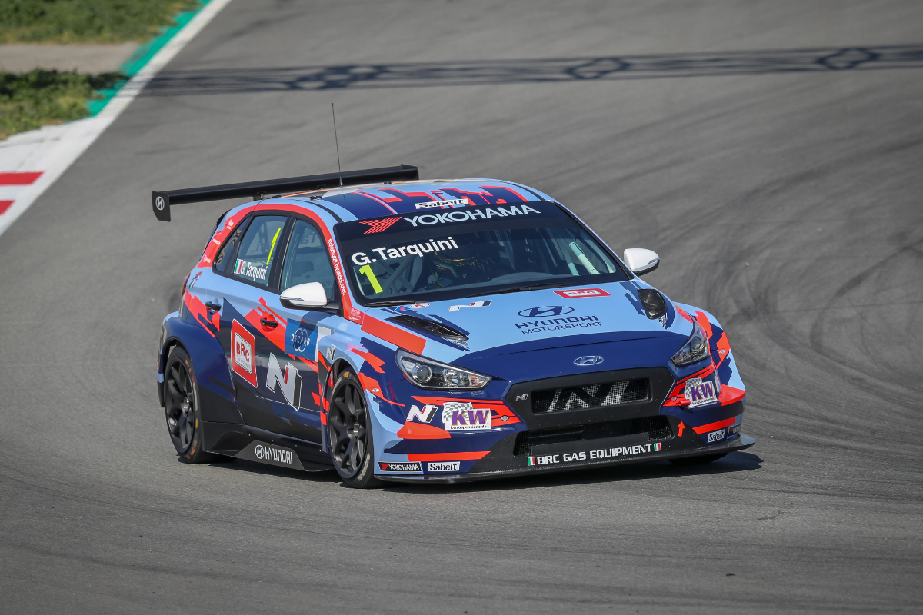

*Gabriele-Tarquini at the recent test in Barcelona*

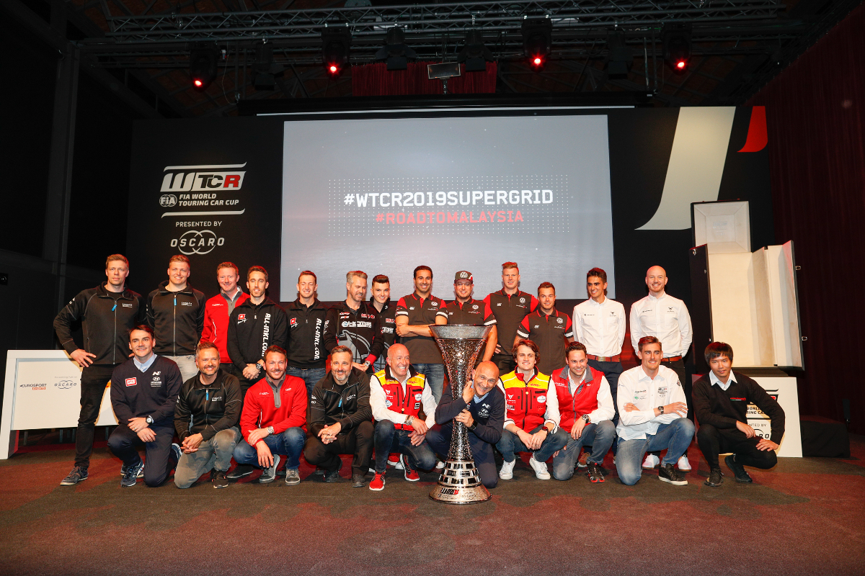

*FIA WTCR Drivers ready for new season Photo F.Lefloch*